PART I: Mark 25



Use the file for creating the tables in MS SQL server

You can use IDT for Universe creations

Proper snapshots explaining all the development with explanations should be sent in the same document

* Display the details like ename,sal,dname grade. Create a break based on dname, at every break display average salary and count of number of employees
* Create a graph showing a ename with the salary add a parameter for Dname. Based on the selection the graph must display the bar chart.
* Create a hierachical display of the data grade>job->ename with the change in measure column of average salary.
* Create a report with Department details [Department number must be prompted] showing the Total Salary, Average Salary, Minimum Salary and Maximum Salary in each department and also get the count of employees .

Part II: (10 Marks)

Using Island Resort Marketing Universe:

**1.**

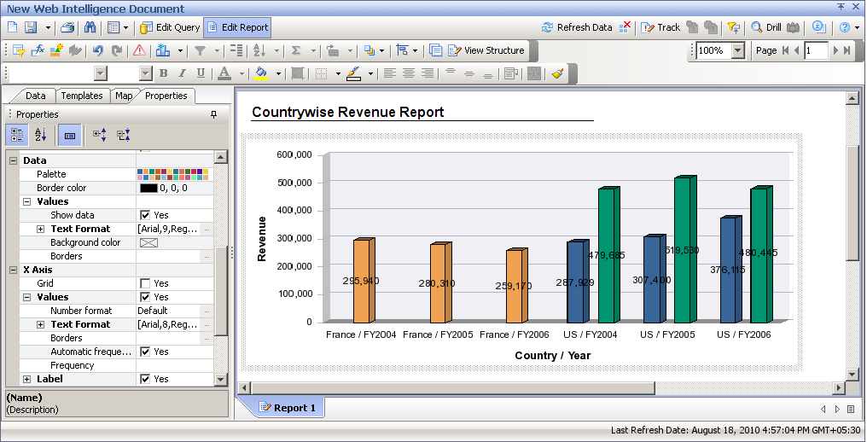

2. Using E-Fashion Universe:(If ‘California’ then the Targeted Revenue is 10% and for other cities its 15%)

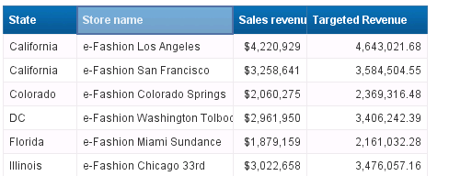

3. Using E-Fashion create the following report ( ‘Top Performers ‘ > 750000, ‘Average performers’ when the range is between 200000 and 700000, ‘Poor Performers’ < 200000) with ‘Top performers’ sales revenue highlighted with green color.



